

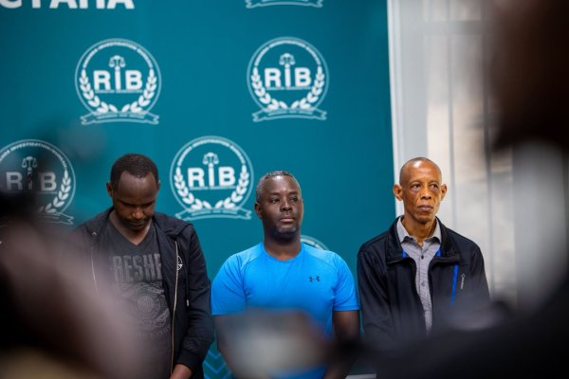

Prof Emile Bienvenu wa Rwanda FDA yafunzwe
13-08-2026 - saa 12:41, Léonidas Muhire
Urwego rw’Igihugu rw’Ubugenzacyaha, RIB, rwerekanye abantu 18 barimo Prof Emile Bienvenu, Umuyobozi Mukuru w’Ikigo cy’Igihugu gishinzwe ubuziranenge, Imiti n’Ibiribwa, Rwanda FDA.
Prof Emile Bienvenu ari mu bantu RIB yerekanye ku wa 13 Kanama 2026. Aberekanywe bose ni abakozi ba Leta barimo 10 bakorera Rwanda FDA.
Harimo kandi abakozi b’Ikigo cy’Igihugu gitsura Ubuziranenge (RSB), hamwe n’Abanyamabanga Nshingwabikorwa b’utugari n’imirenge.
Abantu 10 ba Rwanda FDA harimo Dr Nyirimigabo Eric ukuriye ishami ry’ibiribwa, Dr Nyamwasa uyobora ishami rishinzwe ubugenzuzi, harimo kandi Christian Namahoro, inzobere mu gutanga impushya ku bigo bikora ibiribwa, Muhimpundu Alice, inzobere mu bugenzuzi bw’ububiko n’ahacururizwa ibirbwa, Kangabe Benitha, inzobere mu ikoranabuhanga ry’ibiribwa n’ubugenzuzi, Uwamahoro Elizabeth, inzobere mu mutekano w’ibiribwa no gukurikirana imikoreshereze y’umutekano wabyo.
Harimo kandi Niyigena Claudine, inzobere mu bugenzuzi bw’ububiko n’ahacururizwa ibiribwa, Ndayishima, inzobere mu gukurikirana imiti y’abantu nyuma yo kujya ku isoko, na Nizeyimana Janvier, inzobere mu by’ubwubatsi bw’inganda zitunganya ibiribwa
Umuvugizi wa RIB, Dr. Murangira B. Thierry, yavuze ko kuva ku wa 20 Nyakanga 2026 hamaze gutabwa muri yombi abantu 104 bakurikiranyweho ibyaha bifitanye isano no gutunganya ibinyobwa bisembuye bitujuje ubuziranenge, muri bo 97 bakaba barakorewe dosiye ndetse zishyikirizwa Ubushinjacyaha.
Ati “Iperereza ry’ibanze ryagaragaje ko hari ibyangombwa yagiye atanga adashingiye ku myanzuro ya ka kanama ka tekinike [Internal Technical Licensing Committee.] Twumvise neza ko kariya kanama umwanzuro wako ari wo ashingiraho.”
Yatanze urugero ku bugenzuzi bwakozwe ku ruganda rukora ibinyobwa bisembuye hasangwamo imashini ikamura umutobe ufite ingese nyinshi.
Ati “Ni ikintu giteye ubwoba utareka, biza kurangira urwo ruganda rwahawe icyangombwa kandi noneho icyemezo cyo gutanga icyangombwa kidashingiye ku mwanzuro w’akanama ka tekiniki. Iperereza ryagaragaje ko tariki 23 Mata 2026 Umuyobozi Mukuru wa Rwanda FDA yatanze icyangombwa cyitwa FBO [Food Business Operations License] ihabwa umuntu wujuje ibyangombwa bitatu…ku itariki 19 Gicurasi ako kanama kasuzumye raporo y’abagenzuzi bemeza ko uru ruganda rudahabwa iki cyangombwa. Ariko byumvikane ko basuzumye icyangombwa cyamaze gutangwa.”
No muri RSB hari abafunzwe..
Mu bantu RIB yerekanye harimo abakozi ba RSB bashinzwe gutanga ibyangombwa bitandukanye bakekwaho ibyaha binyuranye.
Abo ni Mporanzi Samuel, umuyobozi w’ishami rishinzwe gutanga impamyabushobozi z’ubuziranenge ku rwego rw’igihugu, Kanyange Celine, umuyobozi w’ishami rishinzwe gutanga impamyabushobozi z’ubuziranenge bw’ibicuruzwa, Kabanda Eric, umuyobozi w’ishami rishinwe gutanga impamyabushobozi z’ubuziranenge bwa systeme,
Hari kandi abakozi batatu bo muri RSB bakurikiranweho icyaha gishingiye ku gutanga icyangombwa cya S-Mark, gihamya ko igicuruzwa cyujuje ubuziranenge, aho bagihaye ibigo birenga 18 kandi ibyo bicuruza bitujuje ibyangombwa bisabwa na Rwanda FDA.
Dr. Murangira yavuze ko ubusanzwe kugira ngo S-Mark itangwe na RSB, umucuruzi cyangwa uruganda rubanza kubisaba, hanyuma hakarebwa niba igicuruzwa cyujuje ibisabwa na Rwanda FDA, ari bwo gihabwa icyangombwa.
Ati “Twasanze nk’ikinyobwa runaka gifite S-Mark, ariko wajya kureba muri bya byangombwa bya Rwanda FDA ugasanga nta kimwe gifite. Ni ibintu byateye icyuho kinini, kuko ari byo byabaye nyirabayazana w’aka kavuyo ko kubona ibicuruzwa ku isoko bitujuje ubuziranenge.”
Dr. Murangira yasobanuye ko abakozi bo mu nzego z’ubugenzuzi bw’ubuziranenge batawe muri yombi bahuriye ku cyaha cyo gukoresha ububasha bafite mu nyungu bwite ndetse hamwe no kudakora igitegetswe mu nyungu zabo bwite, kuko ubusanzwe abakozi bashinzwe ubugenzuzi bw’ubuziranenge bemerewe gufunga ibicuruzwa bitujuje ibisabwa.
Ibyo ariko ntabyo bakoze, kandi bigaragara ko ari mu nyungu zabo bwite kuko bakingiraga ikibaba abakora ibitemewe ariko byangiza ubuzima bwa benshi.
Ati “Ziriya nganda zose zafunzwe zarakoraga zikunguka, zikinjiza amafaranga kandi zidafite ibyangombwa. Ni ukuvuga ko bariya bashinzwe gutanga ibyangombwa bishe ijisho, birengagiza nkana, bahesha inyungu abantu batari bakwiye kubona.”
Ni nyuma y’uko mu Rwanda hafunzwe inganda zirenga 150 zakoze ibinyobwa bisembuye bitujuje ubuziranenge.
Dr. Murangira yavuze ko Abanyamabanga Nshingwabikorwa b’utugari n’imirenge batanu batawe muri yombi bakurikiranyweho icyaha cyo kuba ibyitso ku cyaha cyo guha umuntu ikintu gishobora kwica cyangwa gushegesha ubuzima.
Iki cyaha bakurikiranyweho bagikoze mu buryo bwo gukorana na ba nyir’inganda, bakajya bababurira cyangwa zaba zafunzwe bakongera kuzifungura bidakukirikije amategeko.
Ati “Hari aho twajyaga mu bikorwa byo gushaka aho biriya binyobwa byengerwaga, kubera ko tuba dukorana n’inzego z’ibanze, tugasanga barabuburiye. Muri aba harimo n’abafashwe nyuma y’uko muri iyi minsi ziriya nganda zimaze gufungwa basubiye inyuma bemerera ba nyirazo kongera gukora.”
Aba Banyamabanga Nshingwabikorwa ngo bongeye gufungura izi nganda babwira ba nyirazo ko ari ibintu by’igihe gito bizahita birangira, gusa Dr. Murangira yashimangiye ko amazi atakiri ya yandi, kuko ubu n’abazihaga ibyangombwa bidakurikije amategeko batangiye gufatwa.
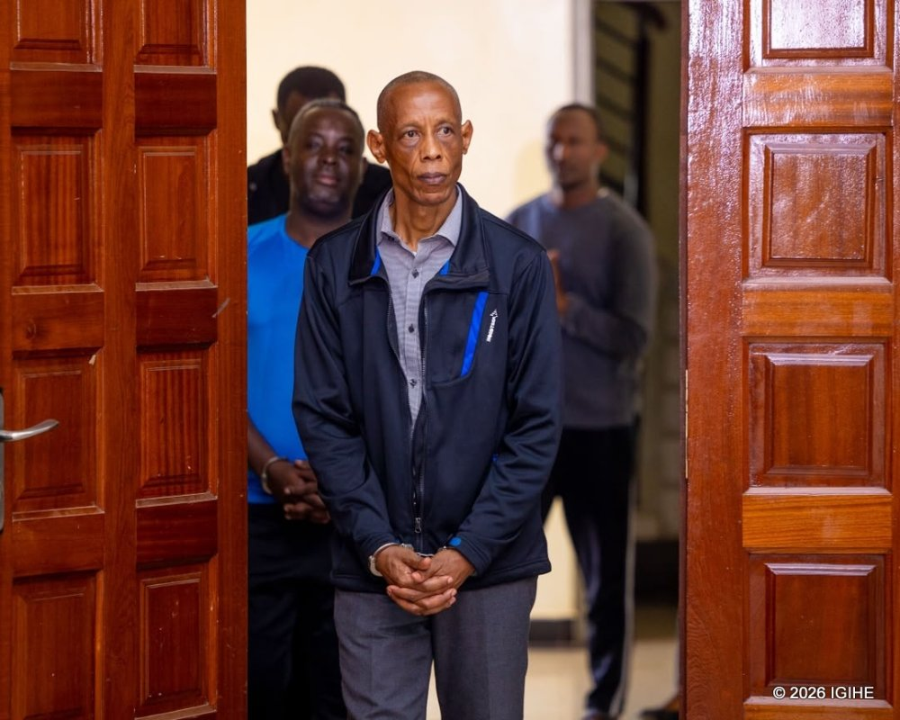
Prof Emile Bienvenu ni Umuyobozi Mukuru wa Rwanda FDA
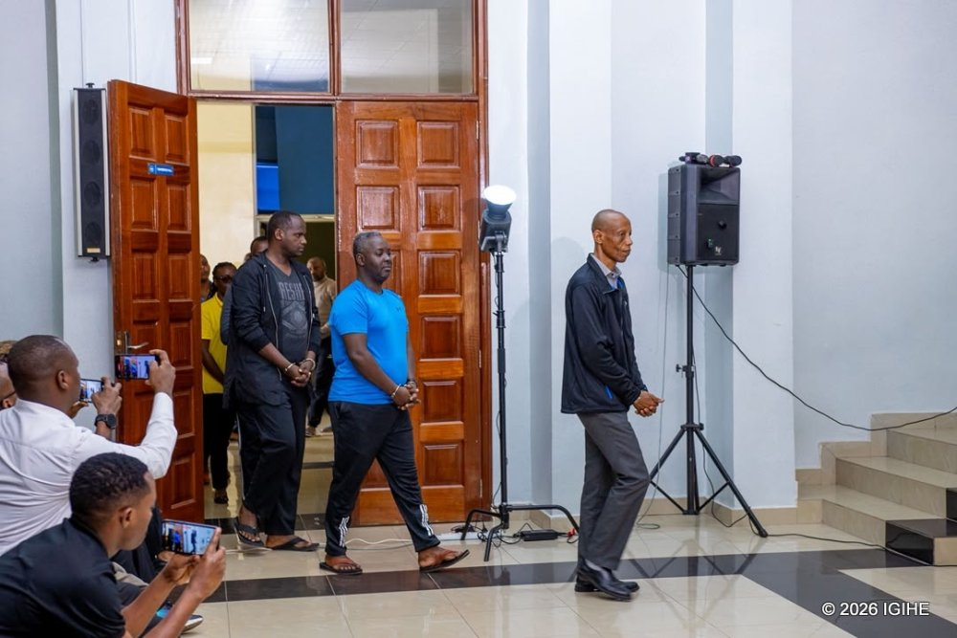
Prof Emile Bienvenu (uri imbere) yatawe muri yombi
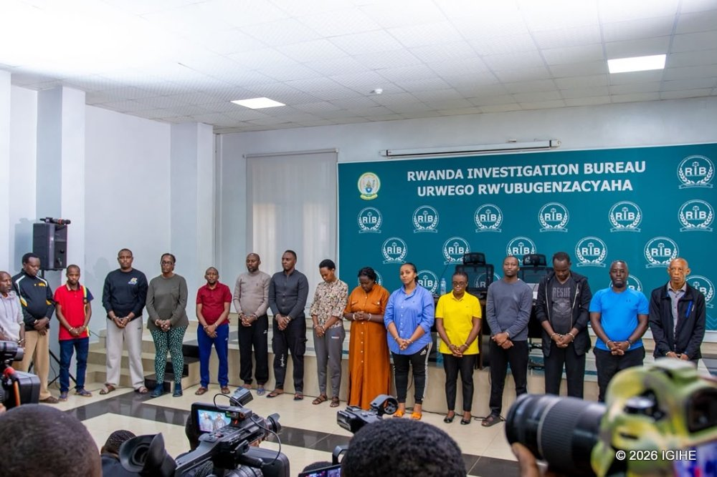
Abantu 18 batawe muri yombi barimo Umuyobozi mukuru wa Rwanda FDA (ubanza iburyo)
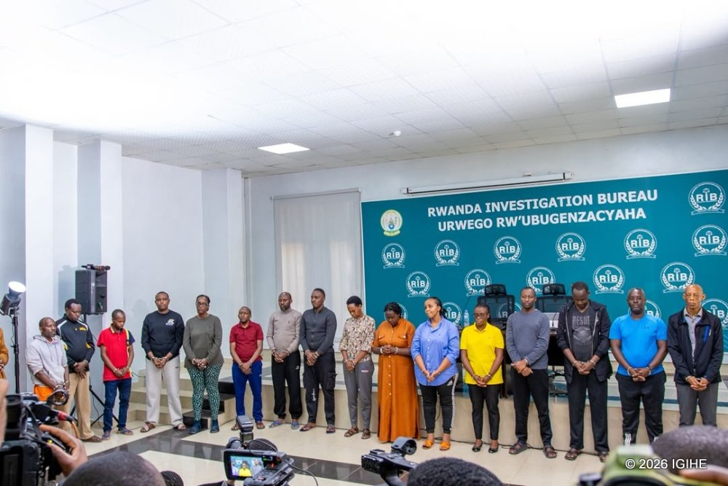
Kwamamaza

Kwamamaza


Izindi nkuru wasoma
Inzira yahariwe siporo i Rebero igiye igeze he?
0 13-08-2026
Itabi rya ‘vape’ ntiryemewe- Polisi y’u Rwanda
0 13-08-2026
Abanyamahanga 19 bahawe ubwenegihugu bw’u Rwanda
0 13-08-2026
Bigomba kwirengerwa n’uwakoze kiriya kintu kitujuje ubuziranenge- Dr Murangira
0 13-08-2026
Kwamamaza

TANGA IGITEKEREZO
AMATEGEKO AGENGA IYANDIKA RY'IGITEKEREZO CYAWE
Kwamamaza
- Twandikire
- Duhamagare kuri 4546

- Kwamamaza
- Abo turi bo

